**CN4002-Computer System & Networks**

**Monday 21 March 2022**

**TCA1- (weighting 50%, 90 minutes)**

This will be based on lecture slides, tutorials, and practical exercises presented in the first six weeks of Term 2.

CN4002 Computer Systems and Networks Teaching Schedule 2021/22 for week one -six

|  |  |  |
| --- | --- | --- |
| Week No | Lecturer | Tentative Topics |
| 1 | AE | The Evolution of Computing Devices |
| 2 | AE | Number Systems |
| 3 | AE | CPU and Memory Subsystem |
| 4 | AE | Input/Output Methods |
| 5 | AE | Peripheral Devices |
| 6 | AE | Operating Systems |

**Monday 6 June 2022**

**TCA2- (weighting 50%, 90 minutes)**

This will be based on lecture slides, tutorials and practical exercises presented in the second six weeks of Term 2.

CN4002 Computer Systems and Networks Teaching Schedule 2021/22 for weeks seven -Twelve

|  |  |  |
| --- | --- | --- |
| Week No | Lecturer | Tentative Topics |
| 7 | HH | Network Fundamentals |
| 8 | HH | Network Protocols and Models |
| 9 | HH | Network Access |
| 10 | HH | Ethernet |
| 11 | HH | IPv4 Addressing |
| 12 | HH | Subnetting IP Networks |

READING AND RESOURCES:

CORE:

Englander, I. S. (2013) The architecture of computer hardware, systems software and networking: an information technology approach. 5th edn. Oxford: Wiley-Blackwell. Tomsho, G. (2016) Guide to Networking Essentials. 7th edn. Boston: Course Technology, Cengage Learning.

Reference Textbooks:

Stallings, W. (2012) Computer organisation and architecture: designing for performance. 9th edn. London: Pearson Eductation. Tanenbaum, A. and Wetherall, D.J. (2013) Computer Networks. 5th edn. Pearson New Internantional Edition.

///////////////////////////////////////////////////////////////////////////////////

**CN4002 Week-1: 31/1/22-06/02/22**

**Ms. Arisha**

**Tutorial Questions**

**1. Regardless of the type of work to be performed, the function of a computer system is**

a. to entertain its users.

b. to reduce the number of employees required by companies.

c. to transform inputs into outputs.

d. to increase company profits.

e. none of the above.

**2. All computer systems, no matter how complex, consist of:**

a. at least one CPU and memory to hold programs and data.

b. at least one CPU, I/O devices and long-term storage.

c. at least one CPU, memory to hold programs and data, I/O devices and long-term storage.

d. at least one CPU, memory to hold programs and data and longterm storage.

e. at least one CPU, memory to hold programs and data and I/O devices.

**3. Which of the following statements correctly describes Von Neumann's architecture?**

a. Memory locations can only be addressed by their content. ο

b. Memory is addressed by location regardless of the data it contains.

c. The CPU needs to be addressed.

d. The CPU can be moved from one location to another.

e. Memory need not be addressed.

**4. The function of the Control Unit (CU) within the CPU is to:**

a. perform arithmetic and Boolean logic calculations.

b. move instructions and data between the CPU and other hardware components.

c. carry signals and power between different computer components.

d. control the processing of instructions and the movement of data within the CPU.

e. performs none of the above.

**5. The function of the Arithmetic and Logic Unit (ALU) within the CPU is to:**

a. perform arithmetic and Boolean logic calculations.

b. move instructions and data between the CPU and other hardware components.

c. carry signals and power between different computer components.

d. control the processing of instructions and the movement of data within the CPU.

e. track the status of the CPU.

**6. Modern computer systems are based on von Neumann’s architecture. With reference to the von Neumann architecture, which of the following statements is TRUE?**

a. Main memory stores both programs and data.

b. Memory is addressed by location regardless of its contents.

c. Data is processed in a binary form.

d. The CPU contains both an Arithmetic and Logic Unit and a Control Unit.

e. All of the above statements are TRUE.

**7. In 1801, Joseph Marie Jacquard invented a loom which was the first documented application of the use of:-**

a. a digital computer.

b. a device which could be used to perform calculations.

c. a device which could store data.

d. a device which could process data in binary form.

e. punched cards to hold a program for the use of a semi-automated, programmable machine.

**8. Which of the following statements most accurately describes a multicore computer?**

a. A system which uses multiple CPUs or CPU cores to function.

b. A system that enables multiple users to simultaneously access the resources of the computer system.

c. A system that allows the user of the computer system to run multiple programs simultaneously.

d. A system that enables the user to access resources spread over multiple computers.

e. A system that enables multiple computer systems to communicate with each other.

**9. A digital computer system generates, stores, and processes data in** a. a hexadecimal form.

b. a decimal form.

c. an octal form.

d. a binary form.

e. an analogue form.

**10.The main function of the Interface unit (i.e., Network Interface Card) in a computer is to**:

a. performs arithmetic and Boolean logic calculations.

b. move instructions and data between the CPU and other hardware components.

c. carry signals and power between different computer components.

d. control the processing of instructions and the movement of data within the CPU.

e. performs none of the above.

**Week- 2: 07/02/22-13/02/22**

**Number Systems**

**Tutorial Questions**

1. What is the *base* of a number system?

Ans. The number of different digits including zero that exist in the number system.

1. What is the base of the

Binary number system?

Ans: 2

Decimal number system?

Ans: 10

Hexadecimal number system?

Ans:16

1. Each digit in a binary number (known as a bit) can have one of two values. What are these two values?

Ans: The two values are: 0 and 1.

1. How many different values can a digit in a decimal number take?

Ans: 10

What are these values?

Ans: 0,1,2,3,4,5,6,7,8,9

1. Find the value of *n* where

7658 = 7 x *n*2 + 6 x *n*1 + 5 x *n*0

**Ans: The value of n is 8.**

1. Find the values of *a*, *b*, *c*, *d* and *e* where

540316 = 5 x 6*a* + 4 x 6*b* + 0 x 6*c* + 3 x 6*d*+ 1 x 6*e*

***Ans: The values of***

**a=4,**

**b=3,**

**c=2,**

**d=1,**

**e=0**

1. Perform the following calculations. You can check your answers using a calculator.
   1. 11011012 + 101012
      1. **1 0 1 1 0 1**

**+ 1 0 1 0 1**

**……………………….**

1. **0 0 0 0 0 1 0**
   1. 2068 + 478

**206**

**+47 13**

**………………… -(b)8**

**25(c 1) 5 …………………………….**

**=255(Ans) 5 remaining**

* 1. 1012 x 1012

**Ans: 11001 (do the normal multiplication and when you are adding follow the same rule as above.)**

(Hint: we did not cover multiplication in the lecture, but you should be able to work out the answer if you use the same approach as you would when multiplying decimal numbers. Remember that positional number systems all behave in the same way! It is the base that distinguishes them.)

1. Convert 23768 to base 10

Calculation:

|  |  |  |  |  |
| --- | --- | --- | --- | --- |
| Place | 83 | 82 | 81 | 80 |
| Value | 512 | 64 | 8 | 1 |
| Evaluation | 2*512 | 3*64 | 7*8 | 6*1 |
| total | 1024 | 192 | 56 | 6 |

**Answer is- 1024+192+56+6=127810**

**Note to remember- power 0= always 1**

1. Convert 10101112 to base 10.

Calculation:

|  |  |  |  |  |
| --- | --- | --- | --- | --- |
|  |  |  |  |  |
|  |  |  |  |  |
|  |  |  |  |  |
|  |  |  |  |  |

Ans: 8710

1. Convert 78910 to base 6 (using base and carry)

Calculation:

|  |  |  |  |  |
| --- | --- | --- | --- | --- |
|  |  |  |  |  |
|  |  |  |  |  |
|  |  |  |  |  |
|  |  |  |  |  |

Ans:33536

1. Convert 21710 to base 2 (using base and carry)

Calculation:

|  |  |  |  |  |  |
| --- | --- | --- | --- | --- | --- |
|  |  |  |  |  |  |
|  |  |  |  |  |  |
|  |  |  |  |  |  |
|  |  |  |  |  |  |

Answer is

1. How are the equivalents of the decimal numbers 10, 11, 12, 13, 14 and 15 represented in hexadecimal?

**Calculation:**

|  |  |  |  |  |
| --- | --- | --- | --- | --- |
|  |  |  |  |  |
|  |  |  |  |  |
|  |  |  |  |  |
|  |  |  |  |  |

Ans:

1. Convert the following binary number to hexadecimal: **1011110101101.**

**Calculation:**

|  |  |  |  |  |
| --- | --- | --- | --- | --- |
|  |  |  |  |  |
|  |  |  |  |  |
|  |  |  |  |  |
|  |  |  |  |  |

Ans:

1. Convert the following hexadecimal number to binary: **7FE5**

*You will find this table useful whenever you need to convert binary numbers to hexadecimal or vice-versa.*

|  |  |  |  |
| --- | --- | --- | --- |
| Hexadecimal | Binary | Hexadecimal | Binary |
| **0** | **0000** | **8** | **1000** |
| **1** | **0001** | **9** | **1001** |
| **2** | **0010** | **A** | **1010** |
| **3** | **0011** | **B** | **1011** |
| **4** | **0100** | **C** | **1100** |
| **5** | **0101** | **D** | **1101** |
| **6** | **0110** | **E** | **1110** |
| **7** | **0111** | **F** | **1111** |

1. **Stretch Question:**

The following binary number **1.1110** contains both a whole number and a fractional part. The fractional part is to the right of the binary point (sometimes refer to the radix point). We know that moving a bit one place to the left doubles the value of the bit (in terms of place values, 20 becomes 21, 21 becomes 22 and so on) and moving a bit one place to the right halves the value of the bit (22 becomes 21, 21 becomes 20 etc.) What then do the bits in **1.1110** represent and what is this binary number’s equivalent value in decimal?

**Week-3-14/2-20/2/22:**

**CPU and Memory**

**Practice Questions**

Please read the relevant chapters of the essential textbook by Englander before answering these questions.

1. The Little Man Computer (LMC) is a simple model that is used to simulate the operation of a computer.

Summarise the purpose of each of the following key components of the Little Man Computer.

* 1. **Mailboxes**:
  2. **Calculator:**
  3. **Instruction location counter:**
  4. **The little man:**
  5. **In and out baskets:**

1. Summarise the following LMC instructions:
   1. 000- Halt Cob/ coffee break/
   2. 1xx- Add
   3. 2xx- Sub
   4. 3xx- Store
   5. 5xx- Load
   6. 901-Input
   7. 902-Output
2. Fill in the blanks

|  |  |
| --- | --- |
| **Component of CPU** | **Corresponding component of LMC** |
| Arithmetic and logic unit (ALU) | calculator |
| Control unit (CU) | Little Man |
| Program counter (PC) | Instruction Location counter |
| I/O interface | In and out baskets |

1. What is held in each of the following registers?
   1. **Instruction register (IR):** Stores instruction fetched from memory.
   2. **Memory address register (MAR**): memory address register holds the address of the current instruction that is to be fetched from memory.
   3. **Memory data register (MDR):** Memory data register holds the contents found at the address held inthe MAR.
   4. **Status registers:** It is a hardware register that contains information about the state of the processor.
2. What is meant by volatile and non-volatile memory? Give an example of each.

Volatile Memory: Volatile memory is a type of storage whose contents are erased when the systems power is turned off or interrupted.

RAM is a volatile because when you work on a document it is kept in RAM and if your computer loses power then your work is lost as well.

Non-Volatile Memory: A type of computer memory that can retrieve stored information even after having been powered cycled.

Examples are- Hard disk drive-HDD, Solid state drive-SDD, Flash drive-USB

1. Distinguish between the following types of memory:
   1. DRAM-Dynamic RAM

DRAM is one of the most commonly found RAM modules in PC compatible personal computers and workstations. It stores its information in a cell containing a capacitor and transistor.

* 1. SRAM-Static RAM

SRAM is the faster and expensive random-access memory (RAM) that is volatile and uses latching circuitry to store each bit and data is lost when power is removed.

* 1. EEPROM-Electrically Erasable Programmable ROM

It is an operator which allows to use the EEPROM just like an array which is non-volatile memory used for computer systems, smart cards.

* 1. Flash memory: It is designed

1. List the main components of a CPU and describe the function of each component.

Main component of a CPU:

ALU-Arithmetic Logic Unit: Performs calculation and comparisons.

CU-Control Unit- Performs fetch/execute cycle

Functions:

• Moves data to and from CPU registers and other hardware components

• Accesses program instructions and issues commands to the AL

Memory management unit:

Supervises fetching instructions and data

I/O Interface:

sometimes combined with memory management unit as Bus Interface Unit

**Practical (Week 3)**

**Programming with the Visible Virtual Machine**

The purpose of this practical is to help you develop your understanding of the CPU and memory components of a computer and, in particular, instruction sets and the fetch execute cycle. To do so, you will write a number of programs using a simulator called the Visible Virtual Machine (VVM). The Visible Virtual Machine (VVM) software, based on the Little Man Computer model, was designed and written by Dr Stu Westin of the University of Rhode Island. Although it is a simulation, the operation of the VVM (and the Little Man Computer upon which it is based) does not differ fundamentally from that of a real computer.

Detailed information about the VVM software can be found online at

<http://visible-virtual-machine.software.informer.com/download/>. You can also download a free copy of the software from this site.

**Introduction to Tasks**

The VVM software has already been installed on the computers in your laboratory. To start the software from within Windows 10, go to

Start → Programs → Visible Virtual Machine 5.0.5 → Visible Virtual Machine

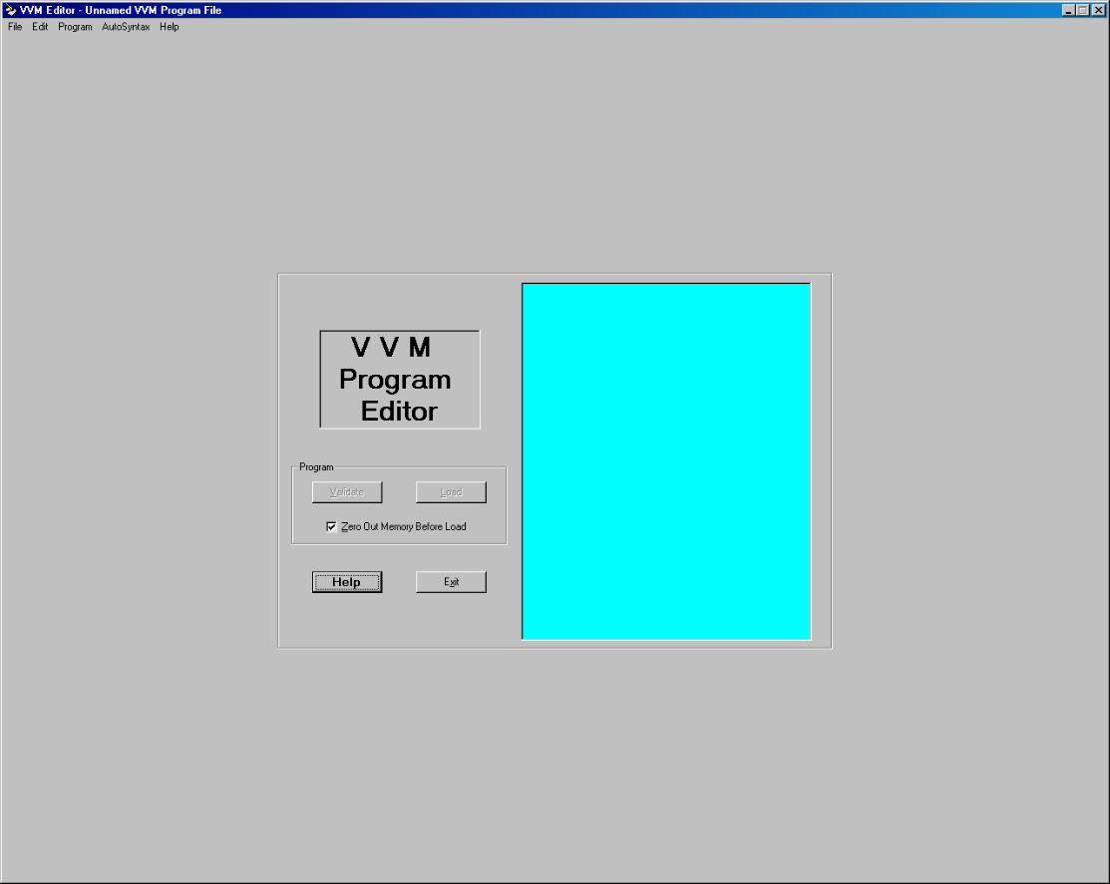

Carefully read through the notes available from the Help option in the VVM, paying particular attention to the VVM instruction set i.e. LDA, ADD, SUB, STO, IN, OUT, HLT etc.

Note also that the instructions you write for the VVM do not explicitly include the addresses of the mailboxes into which they will be loaded. Instead, your program is simply loaded into the mailboxes in sequence starting at 00. This is not very useful if you want to store data rather than instructions, because it is likely that you will want the data to be stored in high-numbered mailboxes well away from the program instructions themselves.

To force the VVM to use a mailbox other than the next one in sequence, you use an asterisk followed by the mailbox address, for example:

*98

The VVM then continues to use mailboxes in sequence, starting from the address you have specified.

You can add comments to your programs using a double slash at the front of the line – the VVM will ignore these lines rather than attempt to interpret them as instructions, for example:

// This is a comment

You can add further comments to your programs on each instruction line – everything after the instruction itself is ignored by the VVM. For example:

LDA 96 Put contents of box 96 in calculator

**Tasks**

You are now ready to write Little Man Computer programs using the Visible Virtual Machine.

You should save each of your programs as a file with a .vvm extension. Remember to add comments to your programs.

Use the 'Step' facility rather than 'Run' so that you can follow the progress of your programs one step at a time, paying close attention to the changes in the PC, IR and accumulator at each step. The 'Trace View' option creates a table tracking these values.

You may find it useful to run through your program on paper before running it in the VVM. You can then compare the way you think your program will behave with the table generated in the VVM's Trace View to check your understanding of Little Man Computer programs.

1. Using the VVM, write the following LMC program (adapted from fig. 6.2, p.184 of Englander) which inputs two numbers, adds them together and outputs the result.

|  |  |  |  |
| --- | --- | --- | --- |
| **Mailbox** | **Code** | **Instruction** | **Description** |
| 00 | 901 | IN | Input first number (***xxx***, say) into calculator |
| 01 | 399 | STO 99 | Store number from calculator (***xxx***) in mailbox 99 |
| 02 | 901 | IN | Input second number (***yyy***, say) into calculator |
| 03 | 199 | ADD 99 | Add value in mailbox 99 (***yyy***) to number from calculator (***xxx***). Calculator now holds the sum. |
| 04 | 902 | OUT | Output number from calculator (***xxx*** + ***yyy***) |
| 05 | 000 | HLT | Stop. |

Choose some example inputs and work through each of the stages to check that your VVM program does indeed add two numbers together. Be aware that the VVM cannot handle large numbers i.e. greater than 999.

Now compare your VVM program with the following :

// Program to input two numbers, add

// them together, and output the result.

//

in Input first number

sto 99 Store in box 99

in Input second number

add 99 Add value from box 99

out Output result

hlt End program

Your VVM program may not be exactly the same as the above, but should be similar. One likely difference is that you may have used other locations for data storage – the program above used the highest-valued box available (i.e. 99). A more important difference may be in the length of your program. If your version has more instructions that the answer above, check through your program and see if you can improve its efficiency by using fewer instructions to complete the task.

Little Man Computer web-based simulator: <https://peterhigginson.co.uk/lmc/->

1. Write a VVM program which inputs two numbers, subtracts the second number from the first and outputs the result.

|  |
| --- |
| Inp  Sto 98  Inp  Sto 99  Lda 98  Sub 99  out  HLT |

1. Write a VVM program which adds the numbers 157 and 13 together and outputs the result.

|  |
| --- |
| Lda 98  Add 99  Out  Halt  *98 |

1. Write VVM programs to do the following:
   1. Input a number, add 100 to it and output the result. The number 100 should be placed in a memory location prior to running the program.

|  |
| --- |
| Inp  Add 70  out  Hlt  *70  Dat 100 |

* 1. Input a number, double it, and output the result.

|  |
| --- |
| Inp  Sto 70  Add70  out  hlt |

* 1. Input a number, double it, subtract 1, and output the result.

|  |
| --- |
| Inp  Sto 70  Add70  Sub 71  out  hlt  *71  dat 001 |

* 1. Input three numbers and output the sum.

|  |
| --- |
| Inp  Sto 98  Inp  Sto 99  Inp  Add 98  Add 99  Out  hlt |

* 1. Input three numbers, add the first two together, subtract the third from the sum, and output the result.

|  |
| --- |
| Inp  Sto 60  Inp  70  Add 60  Inp  Add 70  Out  hlt |

Week-4-21/Feb/22-27/Feb/22

**Week 4 – Input-Output Methods**

**Practice Questions**

1. Why is programmed I/O used mainly for keyboard input, rather than for other I/O devices such as printers and displays?

Ans: Programmed I/O is only for individual data word transfer-a full fetch-execute instruction cycle is performed for every data word transfer, and so programmed I/O is shown. For keyboard input, this is not a problem-although programmed I/O is shown compared with the computer itself.it is still much faster than even the most proficient user typing characters at the keyboard. Because the data being transferred I/O is suitable for use with keyboards.

Devices such as printers and displays require faster data transfer than would be possible using programmed I/O because they work with large blocks of data- it would be very inefficient to transfer these large blocks one data word at a time.

1. A program is executing when a number of interrupts occur:

* Interrupt B
* followed by Interrupt A
* followed by Interrupt C

(Assume that interrupts A, B and C originate from different devices and therefore require the attention of different interrupt routines.)

Draw a diagram to show the sequence of events for dealing with these interrupts, given the following information:

* 1. Interrupt A has the lowest priority and interrupts C the highest priority.
  2. Interrupts A and C occur before the interrupt routine for B has finished servicing interrupt B.

How would the diagram change if interrupt B had the highest priority and interrupt A the lowest?

1. Consider the interrupt that occurs at the completion of a disk transfer and answer the following questions.
   1. “Who” is interrupting “whom”?
   2. Why is the interrupt used in this case?
   3. Describe the steps that take place after the interrupt occurs.

Ans: When the interrupt occurs, the CPU suspends the execution of the program being executed, then it saves the crucial parameters for later return to that program and jumps to an interrupt handler program. The interrupt handler notifies the program that the data is available for use. Control is then returned to the program.

1. What role does programme I/O play indirect memory access?

Ans: Programmed I/O is used to initiate direct memory access. To initiate DMA, programmed I/O is used to send the following information:

* The location of the data on the I/O device
* The starting location in memory
* The size of the block
* Whether it is a red or white operation.

1. Assume that a block of data is being written to an output device using DMA. Whilst the data transfer is taking place, the CPU is free to perform other tasks – so it runs another program. Now assume that this program alters the value in one of the memory locations involved in the data transfer. There is no way of knowing whether the data has been altered before or after the transfer of that particular location, so the data transferred to the output device may or may not be the original data. How is such an unstable situation avoided?

Ans: The unstable situation is avoided by disallowing any modification to the data being transferred. The program waiting for the data transfer is suspended (or, it may perform processing tasks unrelated to the data being transferred). the CPU, therefore, needs to know when the data transfer is complete so that it can resume the program that has been suspended. This is achieved using a completion signal interrupt.

1. What is Polling? What are the disadvantages of Polling?

Ans: Polling refers to the situation where a device is repeatedly checked for readiness, and it is not the computer returns to a different task. Although not as wasteful of CPU cycles as busy-wait, this is generally not as efficient as the alternative to polling, interrupt-driven I/O.

1. Why is Direct Memory Access (DMA) more efficient than programmed I/O?

Ans: It is more efficient because it transfers data in blocks and frees the CPU to perform other tasks whilst the data transfer takes place.

**Week-4-Practical**

**Advanced Programming with the Visible Virtual Machine**

All of the programs that you have written so far execute instructions in sequence. Branching enables you to execute an instruction out of sequence by telling the CPU to ‘jump’ to an instruction other than the next one in the sequence.

Write VVM programs to do the following (each program requires one or more branching instructions).

1. Find the positive difference between two inputs i.e. subtract the smaller of the two inputs from the larger and output the result.
2. Input two numbers. If the two numbers are equal, output the value 1, otherwise output the value 0.
3. Input two numbers. Output the larger of the two numbers.
4. Output the numbers 1 to 10 in descending order.
5. Output the numbers 1 to 10 in ascending order.

**Week 5 – Computer Peripherals**

**Practice Questions**

1. Summarise the key differences between primary and secondary storage. Why do computer systems require both primary and secondary storage?

**Answer:**

* Primary storage refers to computer storage which is direct access by CPU (Central Processing Unit) or processor.
* Primary storage includes RAM (Random Access Memory) and fast Cache storage.
* Primary storage is generally very first but expensive.
* Primary storage is generally volatile (data in the storage gets lost when a computer or device turns off).
* Secondary Storage refers to storage devices capable of storing long-term persisted data. These devices include Hard Disk Drive (HDD), Solid State Drive (SSD) or Flash Drives.
* These storage mediums are non-volatile which means it can keep the data persisted even if power is turned off.
* Secondary storage is slower than compared to primary storage and hence cheaper than well. Solid-State Drive is significantly faster than traditional Hard Disk Drives and helps boost system performance.

Needs of primary and secondary keys for a computer:

Primary memory is a fast access memory. Files of the application which are being currently running on the system are loaded in it which are important for working off that app. e.g. RAM, ROM

Secondary storage is used to store a large amount of data, like pictures, videos, etc. It is slower than the primary memory e.g. Hard Disk, CD.

1. Solid-state drives (SSDs) are rapidly replacing magnetic disks as the preferred method of secondary storage in laptops. Why?

**Answer:**

1. A magnetic disk spins at 7,200 revolutions per minute. Calculate the disk’s average latency. (Average latency = ½ * 1/rotational speed). Calculate the disk’s transfer time for a single block assuming that each track on the disk contains 30 sectors. (Transfer time = 1/(# of sectors * rotational speed))

**Answer:**

1. What is meant by the term *seek time* in the context of magnetic disks? When will seek time be at its maximum?

**Answer:**

Seek time is the time taken for a hard disk controller to locate a specific piece of stored data.

The maximum seek time is the full stroke of time.

The maximum seek time is the time it takes to seek overall tracks (from the innermost to the outmost or vice versa.)

1. Mirrored arrays can improve both system reliability and disk performance. Explain how these improvements are achieved.

**Answer:**

1. Striped arrays provide error checking capabilities which allow systems to recover in the event of a disk failure. Explain how these error checking capabilities work.

**Answer:**

1. A true-color image with a resolution of 1,920 x 1,080 pixels (ie high definition) will require how much storage? How much storage would a true colour, ultra-high-definition image (3,840 x 2,160 pixels) require?

**Answer:**

1. Both inkjet and laser printers use dots to print images on paper. How are those dots transferred onto the paper?

**Answer:**

**Topic 6 - Operating Systems**

**Tutorial Questions**

1. What is meant by 'dispatching'? What objectives do you think should be met by the dispatcher?
2. The dispatcher for a system may be classified as pre-emptive or non-pre-emptive. What is the difference between these two systems?
3. Summarise the purpose of each of the following operating system components:
   1. File management system
   2. Process control management
   3. I / O management
   4. Memory management
   5. Bootstrap program
4. What are the limitations of computer system that has no operating system? How will it be possible to load and execute programs?
5. What is the difference between multitasking and multiprocessing?
6. List and explain some definite advantages to the use of a graphical user interface (GUI) over a command line interface (CLI) and vice versa. What is the target audience for each type of interface?

**Practical (Week 6)**

**A Brief Introduction to the Windows Command Line**

In this practical, you will explore the Windows command line interface. Whilst all of you have used the graphical user interface (GUI) provided by Windows 10, many of you will not have used or even be aware of the facilities that Windows 10 provides its users for interacting with the system via the command line (CLI). The command line may seem strange and difficult to understand at first but it provides a range of powerful features which are used everyday by advanced users such as software engineers, system administrators and cyber security analysts.

**Accessing the Windows Command Line**

There are several ways to access the command line in Windows 10. Try the following. In each case, make a mental note of what happens.

1. You can use the address bar in Internet (or File) Explorer, which you can find in Windows Accessories.

Click on the Windows icon at the bottom left corner, scroll to Windows Accessories and click on Internet Explorer: You will see the following displays.

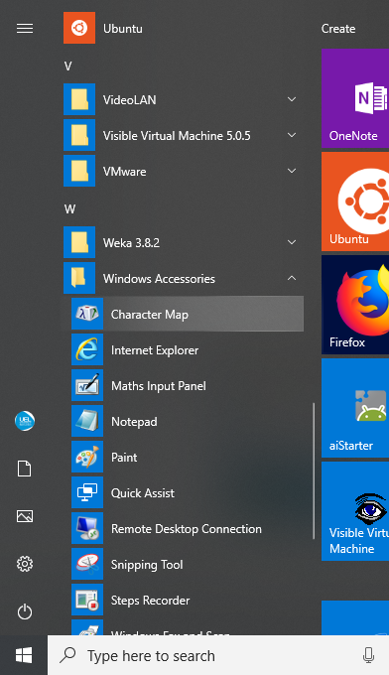

Enter: c:\windows\system32\notepad.exe

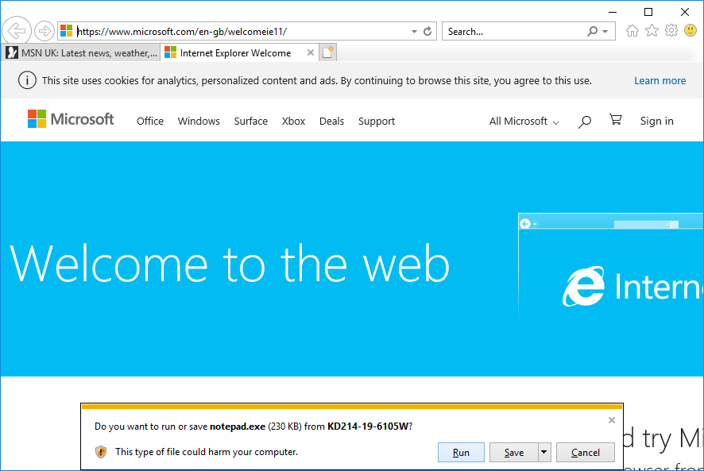

When prompted by this window, click on Run.

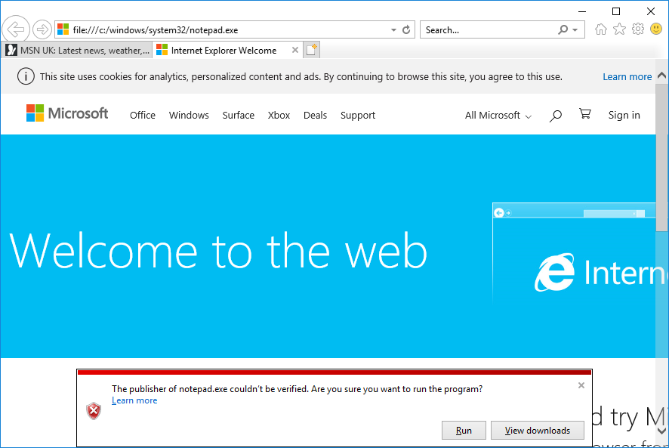

Click Run again.

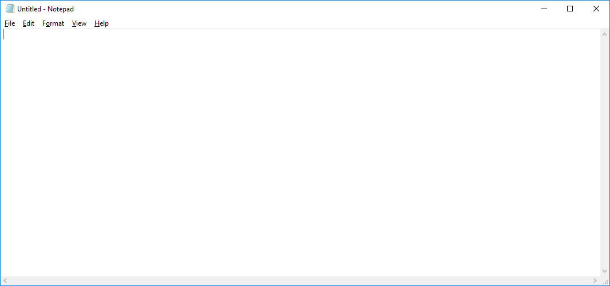

1. Press the Windows key (between Ctrl and Alt keys) and R [Win + R]. When prompted with the following window, type notepad.

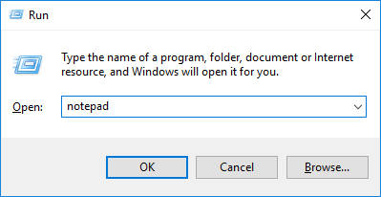

1. Go back to the Windows main menu (Click on the Windows icon), scroll to Windows System. Click on it. Which applications are displayed under Windows System?

Answer:

Command Prompt, Control Panel, File Explorer, Run, Task Manager, This PC, Windows Administration Tools

1. Click on Command Prompt.
2. Go back to Windows System.
3. Click on Run and type cmd.
4. Type cmd in the search box in the Windows bar (bottom) and press Enter.

What is the difference between actions a, c and d?

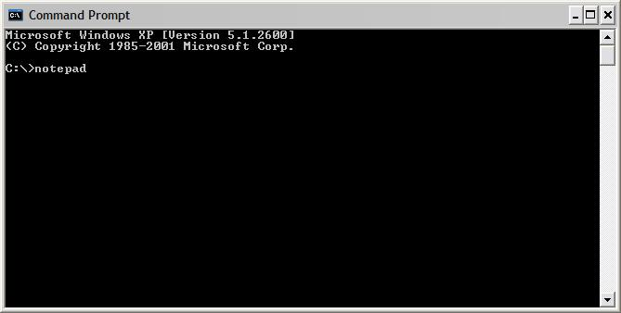

If all went well, the command prompt should have appeared on the screen in all three cases. Now repeat the above steps but this time use the *netstat* command. What happens this time? In the case of steps c. and d. the output from the *netstat* command appears in a window momentarily but not long enough for you to view its contents. In the case of step a., the Command Prompt window remains open after the *netstat* command has finished. *Netstat* (a very useful command for network analysis) is an example of what Windows calls a console application. Unlike *notepad*, which requires the Windows desktop GUI to run, console applications need to be run using the command prompt.

What does netstat do?

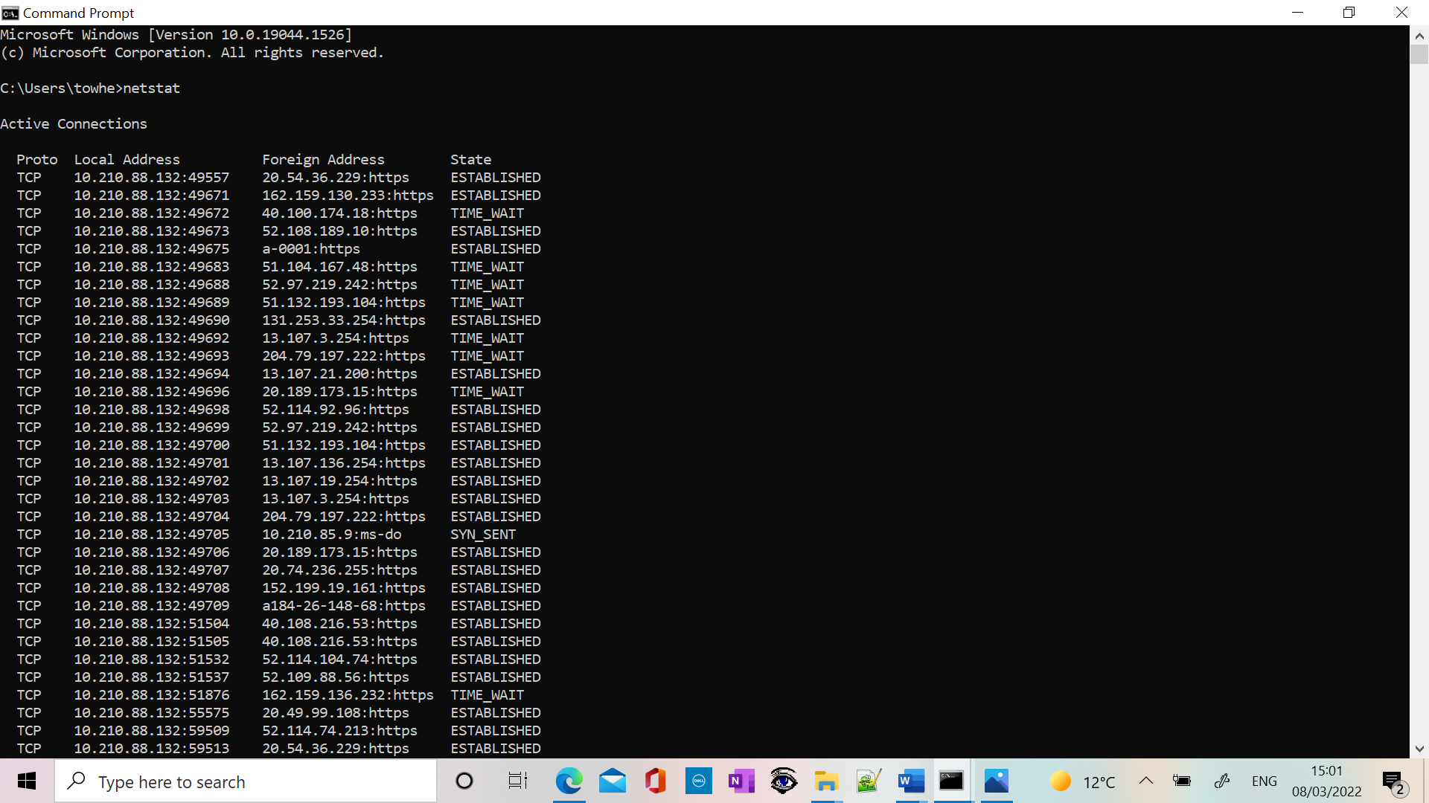

From now on, you will need to use the command prompt.

**Windows Command Prompt Basics**

Enter *cmd* in the run dialog on the start menu.

**Getting Help with Windows Commands**

You can get help for a Windows command by typing the *commandname /?*, e.g. *dir /?*

Enter *set /?* to find out about the set command. Make some brief notes.

|  |
| --- |
|  |

**Useful Windows Commands**

The following list contains a number of useful Windows commands. Try each one of them, making a note below of what they do. (Remember, if you aren’t sure, use the Windows help system.)

1. *cd*
2. *cd ..*
3. *cd \windows\system32*
4. *cls*
5. *dir*
6. *dir /q*
7. *dir /ad*

**Redirection**

The Windows command line interface will also let you redirect input and output. Normally the command prompt writes the output from a program to the screen (referred to as the standard output) and reads data into commands from the keyboard (referred to as the standard input). Using redirection, we can alter this behaviour. The following exercises will clarify these points.

Before 1, enter *exit* to close the current command prompt and open a new one so that you are back in your home directory.

1. *echo a line of text*
2. *echo a line of text > textfile*
3. *type textfile*
4. *copy textfile newtextfile*
5. *ren newtextfile oldtextfile*
6. *del textfile oldtextfile*

After 4, 5 and 6, enter *dir* to check what changes have taken place to the files in your directory (folder). If there are a large number of files in the directory, enter *dir /p* to view them one screen at a time.

Make some notes below.

|  |
| --- |
|  |

**Pipes**

Pipes are used to redirect the standard output from one command into the standard input of a second command.

The Windows command line interface supports this feature. To illustrate this, open a new command prompt and enter the following commands, making a note below of what they do:

1. *dir > mylist.txt* (followed by *more mylist.txt* to display the contents of mylist.txt. Pressing the space bar causes the *more* command to scroll text a whole screen at a time.)
2. *dir c:\windows >> mylist.txt* (followed again by *more mylist.txt*)
3. *sort /+12 < mylist.txt*
4. *dir c:\windows | more*
5. *type mylist.txt | sort* (Note that in this case *type* is an actual command. What is the difference between this combination of commands and those in c. above?)
6. *dir c:\windows | find “log” /i | more*

|  |
| --- |
|  |

**Using Wildcards**

The Windows command line support wildcards. Wildcards can be used to manipulate multiple files with a single command. Windows uses two wildcards, * and ?. ‘*’ means zero or more characters whilst ‘?’ means a single character.

Enter the following commands which illustrate the use of wildcards. Make notes below of the differences between the various commands.

i) *dir c:\windows\*log\** (How is this different from f. above?)

ii) *dir c:\windows\*.log* (How is this different from i?)

iii) *dir c:\windows\w\**

iv) *dir c:\windows\?i\**

v) *dir c:\windows\???.\**

vi) *dir c:\windows\????.\** (How is this different from v?)

|  |
| --- |
|  |

Wildcards are extremely useful. As well as using them directly at the command prompt, you can use them within batch files and scripts.

**Environment Variables**

Windows makes use of environment variables. As the name suggests, an environment variable is used to store information about the environment in which a process executes. (Remember that each time we execute a program, a process is created. That process can obtain information about its environment by querying the environment variables.) You can inspect environment variables in Windows by going through

Windows System → Control Panel → System

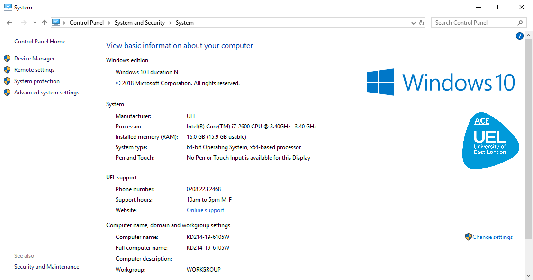

Click on Advanced System Settings.

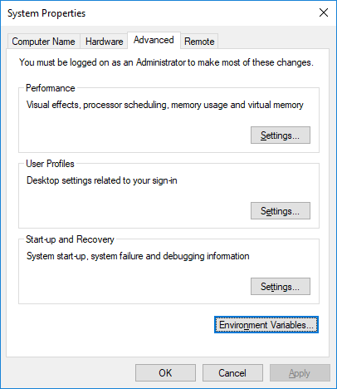

Click on Advanced → Environment variables, making notes of what you find.

|  |
| --- |
|  |

From the command prompt, enter *set* to view the same information.

You can display the value of an individual environment variable using either *set variable* or *echo %variable%*.

Enter the following commands

* *set os*
* *echo %os%*

You should get the same answer! Using either *set* or *echo*, find the values of the following environment variables; *computername*, *comspec*, *homepath*, *path*, *temp* and *username*. What purpose do each of these environment variables serve?

|  |
| --- |
|  |

You can set environment variables using the *set* command.

Enter *set workdir=c:\windows* then enter *echo %workdir%* to check that the variable has been correctly set.

You can also use environment variables within commands.

Enter *cd %workdir%*. Are you in the right directory?

**Command History**

You can scroll through previous commands by pressing the ↑ and ↓ keys.

And finally

enter *exit* to close the command prompt.

In your own time, you should search the Web (www.ss64.com is a good starting point) for Windows command prompt tutorials that will help you to develop your command line skills further.

**MOCK TCA-1**

**Q-1. The function of the Arithmetic and Logic Unit (ALU) within the CPU is to:**

* 1. carry signals and power between different computer components
  2. more instructions and data between the CPU and other hardware components
  3. perform arithmetic and Boolean logic calculations
  4. control the processing of instructions and the movement of data within the CPU.

**Q-2:**

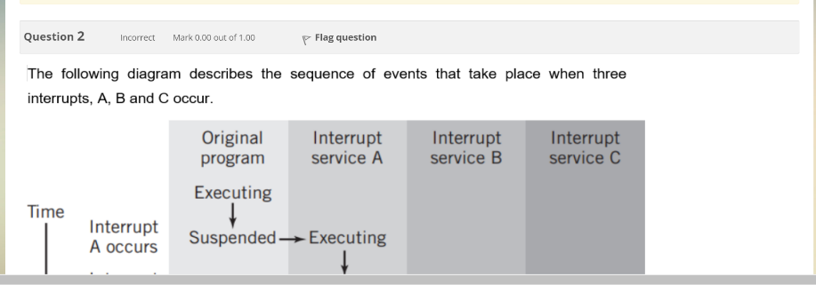

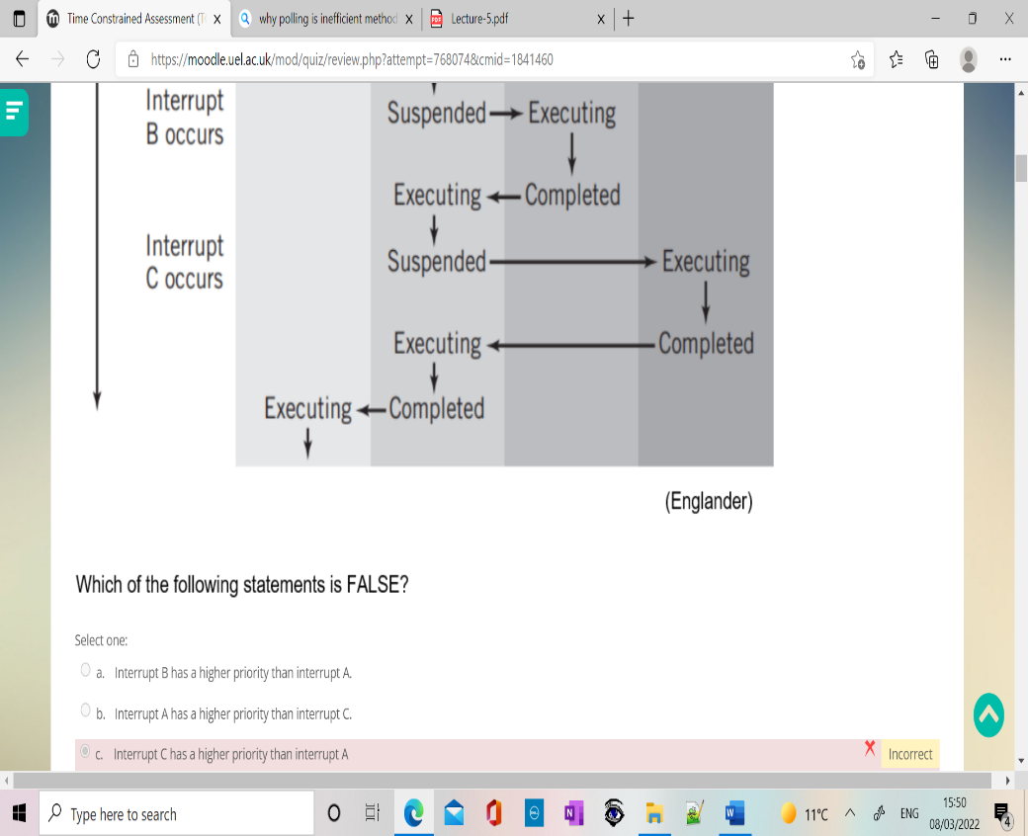

**Which of the following statements is False?**

1. Interrupt B has a higher priority than interrupt A.
2. Interrupt A has a higher priority than interrupt C.
3. Interrupt C has a higher priority than interrupt A.
4. Interrupt A has a higher priority than the original program.

**Q-3. The Little Man Computer (LMC) instruction STO 99 will-**

1. store the contents of mailbox 99 in the calculator.
2. store the value 99 into the calculator.
3. Store the value 99 into mailbox 99
4. Store the value in the calculator into mailbox 99

**Q-4. Which of the following statements most accurately describes a multitasking operating system?**

1. A system that enables multiple users to simultaneously access the resources of the computer system.
2. A system that allows the user of the computer system to run multiple programs simultaneously.
3. A system that enables multiple computer system to communicate with each other
4. A system which requires multiple CPU in a single computer system to function

Q-5. How many bits per pixel are used by a true colour, HD image (1920 x 1080 pixel) to store colour information?

1. 24
2. 1
3. 8
4. 16

Q-6. The base of the decimal number system is

1. 2
2. 8
3. 10
4. 16

Q-7. When the transfer of data from memory to disk using direct memory access (DMA) is complete, a singnal is sent to the CPU. The signal is sent using

1. combination of DMA and an interrupt
2. an interrupt
3. direct memory access (DMA)
4. programmed i/o

Q-8. The result of 1101(power 2 down) +1010(power 2 down) is:

1. 11111([power 2 down)
2. 10111 (power 2 down)
3. 10100 (power 2 down)
4. 1111 (power 2 down)

Q-9. which one of the following statements is true?

**Week 7 –**

**Network Fundamentals**

**Tutorial Questions**

**Q1. Which of the following is not an advantage of networking computers?**

a. Resource sharing

b. Reduced security for data

c. Potential for increased productivity

d. Improved communications

**Q2. What is the minimum number of computers required to form a network?**

a. One

b. Two

c. Three

d. Four

**Q3. What is a protocol?**

a. A type of transmission medium

b. A security agreement

c. A communications agreement

d. A suggested best practice

**Q4. What is the term for any process or way of doing something that works only on a single vendor’s equipment?**

a. Proprietary

b. Standard

c. De facto

d. Registered

**Q5. Which statement is true with regard to a LAN?**

a. Distributed across a large geographical area

b. High speed

c. Leased from a telecommunications company

d. Requires a server

**Q6. Which of the following is the shortcoming of a peer-to-peer network?**

a. Difficult to implement

b. Requires server

c. High cost

d. Network congestion

**Q7. Which term refers to a network that provides secure access to the corporate offices by suppliers, customers, and collaborators?**

a. Extranet

b. Intranet

c. extendednet

d. Internet

**Q8. What characteristic of a network enables it to quickly grow to support new users and applications without impacting the performance of the service being delivered to existing users?**

a. Reliability

b. Quality of service

c. Accessibility

d. Scalability

**Q9. What is an ISP?**

a. It is a protocol that establishes how computers within a LAN communicate.

b. It is an organization that enables individuals and businesses to connect to the Internet.

c. It is a networking device that combines the functionality of several different networking devices in one.

d. It is a standards body that develops cabling and wiring standards for networking.

**Q10. Which device performs the function of determining the path that messages should take through internetwork?**

a. router

b. DSL modem

c. web server

d. firewall

**Q11. Which two Internet connection options do not require that physical cables be run to the building? (Choose two.)**

a. dedicated leased line

b. cellular

c. DSL

d. dialup

e. satellite

**Q12. What type of network must a home user access in order to do online shopping?**

a. an intranet

b. an extranet

c. a LAN

d. the Internet

**Q13. What is the Internet?**

a. It is a private network for an organisation with LAN and WAN connections.

b. It is a network based on Ethernet technology.

c. It provides connection through interconnected global networks.

d. It provides network access for mobile devices.

**Q14. What are two functions of end devices on a network? (Choose two)**

a. They direct data over alternate path in the event of link failures.

b. They provide the channel over which the network message travels.

c. They filter the flow of data to enhance security.

d. They are the interface between humans and the communication network.

e. They originate the data that flows through the network.

**Q15. In which scenario would the use of a WISP (Wireless ISP) be recommended?**

a. an internet cafe in a city

b. any home with multiple wireless devices

c. an apartment in a building with cable access to the Internet

d. a farm in a rural area without wired broadband access

**Week-7 Practical**:

**Week 8 – Network Protocols**

**Tutorial Questions**

Q1. What is the general term that is used to describe a piece of data at any layer of a networking model?

a. frame

b. packet

c. protocol data unit

d. segment **(**is a customer data platform (CDP) that helps you collect, clean, and activate your customer data.)

Q2. At which layer of the OSI model would a physical address be encapsulated?

a. physical layer

b. data link layer

c. network layer

d. transport layer

Q3. Why are open standards important in the data communications industry?

a. They are required for devices to gain access to the internet.

b. They eliminate the threat of security breaches.

c. They enable interoperability between software and hardware from different vendors.

  d. They encourage network organizations to develop proprietary software to retain their competitive edge.

Q4. What is the purpose of protocols in data communications?

a. specifying the bandwidth of the channel or medium for each type of communication

b. specifying the device operating systems that will support the communication

c. providing the rules required for a specific type of communication to occur

d. dictating the content of the message sent during communication

Q 5. The MAC address of a PC does not change when the PC is moved to a different network because the MAC address is embedded in the NIC (Network Interface Card) of the PC.

Q6. What type of delivery uses data link layer addresses?

a. remote delivery

b. local and remote delivery

c. local delivery

d. remote delivery using routers

Q7. If the default gateway is configured incorrectly on the host, what is the impact on communications?

a. The host is unable to communicate on the local network.

b. The host can communicate with other hosts on the local network but is unable to communicate with hosts on remote networks.

  c. The host can communicate with other hosts on remote networks but is unable to communicate with hosts on the local network.

d. There is no impact on communications

Q8. Which message delivery option is used when all devices need to receive the same message simultaneously?

a. duplex

b. unicast

c. multicast

d. broadcast

Q9. Which logical address is used for delivery of data to a remote network?

a. destination MAC address

b. destination IP address

c. destination port number

d. source MAC address

e. source IP address

Q10. What three requirements are defined by the protocols used in network communications to allow message transmission across a network?

a. connector specifications

b. message encoding

c. media selection

d. message size

e. delivery options

f. end-device installation

Q11. Which three acronyms represent standards organizations?

a. IANA

b. TCP/IP

c. IEEE

d. IETF

e. OSI

f. MAC

Q12. What layer of the TCP/IP protocol model determines the best path through the network?

a. application

b. transport

c. internet

d. network access

Q13.Which layer of the OSI model defines services to segment and reassemble data for individual communications between end devices?

a. application

b. presentation

c. session

d. transport

e. network

Q14. What type of message is sent to a specific group of hosts?

a. static

b. unicast

c. dynamic

d. multicast

e. broadcast

**Problem 1:**

**Match the following to one or more layers of the OSI model:**

a. Route determination (network)

b. Flow control (data link and transport)

c. Interface to transmission media (physical)

d. Provides access for the end user (application

**Problem 2:**

**Match the following to one or more layers of the OSI model:**

a. Reliable process to process message delivery (transport)

b. Route selection (network)

c. Defines frames (data link)

d. Provides user services such as e-mail and file transfer (application)

e. Transmission of bit stream across physical medium (physical)

**Problem 3:**

**Match the following to one or more layers of the OSI model:**

a. Format and code conversion services (presentation)

b. Establishes, manages and terminates sessions (session)

c. Ensures reliable transmission of data (data link and transport)

d. Log-in and log-out procedures (session)

e. Provides independence from differences in data representation (presentation)

**Problem 4:**

**Match the following to one or more layers of the OSI model:**

a. Communicates directly with user’s application program (application)

b. Error correction and retransmission (data link and transport)

c. Mechanical, electrical and functional interface (physical)

d. Responsibility for carrying frames between adjacent nodes (data link

**Week 9 - IP Addressing**

**Tutorial Questions A**

1. The subnet mask of an IP address is made of a network portion and a host portion.
2. A subnet mask is a 32*-bit* number that’s always assigned to a host when the IP address is assigned.
3. Fill in the rest of the grid in the table below:

|  |  |  |  |  |  |  |
| --- | --- | --- | --- | --- | --- | --- |
| Class | 1st Octect Decimal Range | 1st Octect High order bits | Network/Host ID | Default Subnet mask | Number of network IDs | Hosts per network (usable addresses) |
| A | ***0-127*** | ***0*** | ***N.H.H.H*** | ***255.0.0.0*** | ***128*** | ***2^24-2=***  16,777,214 |
| B | ***128-191*** | ***10*** | ***N.N.H.H*** | ***255.255. 0.0*** | ***16,384*** | ***2^14-2=65,534*** |
| C | ***192-223*** | ***110*** | ***N.N.N.H*** | ***255.255.255.0*** | ***2097152*** | ***2^8-2=254*** |
| D | ***224-239*** | ***1110*** | ***NA*** | ***NA*** | ***NA*** | ***NA*** |
| E | ***240-255*** | ***1111*** | ***NA*** | ***NA*** | ***NA*** | ***NA*** |

1. Determine the host and network portions of the IP address

|  |  |  |  |  |  |
| --- | --- | --- | --- | --- | --- |
| Host IP address | Address Class | Network Address | Host Address | Network broadcast address | Default subnet mask |
| 216.14.55.137 | **C** | **216.14.55.0** | **137** | **216.14.55.255** | **255.255.255.0** |
| 123.1.1.15 | **A** | **123.1.1.15** | **1.1.15** | **123.255.255.255** | **255.0.0.0** |
| 150.126.221.244 | **B** | **150.126.0.0** | **221.244** | **150.126.255.255** | **255.255.0.0** |
| 194.125.35.199 | **C** | **194.125.35.0** | **199** | **194.125.35.255** | **255.255.255.0** |
| 175.12.239.244 | **B** | **175.12.0.0** | **239.244** | **175.12.255.255** | **255.255.0.0** |

1. A router receives a packet with the destination address 172.19.44.211. Show how the router finds the network address of the packet.

Ans:

Class-B

|  |  |  |  |  |  |  |  |  |  |
| --- | --- | --- | --- | --- | --- | --- | --- | --- | --- |
| Binary |  |  |  |  |  |  |  |  | Decimal |
|  |  |  |  |  |  |  |  |  |  |
|  |  |  |  |  |  |  |  |  |  |
|  |  |  |  |  |  |  |  |  |  |
|  |  |  |  |  |  |  |  |  |  |

See the picture

Default subnet Mas

255.255.0.0

|  |  |  |  |  |  |  |  |  |  |
| --- | --- | --- | --- | --- | --- | --- | --- | --- | --- |
|  |  |  |  |  |  |  |  |  |  |
|  |  |  |  |  |  |  |  |  |  |
|  |  |  |  |  |  |  |  |  |  |
|  |  |  |  |  |  |  |  |  |  |
|  |  |  |  |  |  |  |  |  |  |
|  |  |  |  |  |  |  |  |  |  |
|  |  |  |  |  |  |  |  |  |  |
|  |  |  |  |  |  |  |  |  |  |

1. What is the name of the process of dividing a single network address into two or more subnetwork addresses, each with fewer available host IDs than the original network address.

Ans: Subnetting

1. IPv6 Addresses are specified in Hexadecimal format in 16-bit sections separated by a colon. The first three 16-bit sections (totaling 48 bits) represent the public topology, which could be an Internet backbone or service provider. The next 16 bits represent the site topology, such as a business or a local ISP. The last 64 bits (four 16-bit sections) represent the interface identifier.
2. An IPv6 address is 128 bits rather than the 32 bits in an IPv4 address.

………………………………………End of week 8…………………………………………

**Week 9 - IP Addressing**

**Tutorial Questions B**

**Converting IPv4 Addresses to Binary**

**Objectives**

**Part 1: Convert IPv4 Addresses from Dotted Decimal to Binary**

**Part 2: Use Bitwise ANDing Operation to Determine Network Addresses**

**Part 3: Apply Network Address Calculations**

**Background**

Every IPv4 address is comprised of two parts: a network portion and a host portion. The network portion of an address is the same for all devices that reside in the same network. The host portion identifies a specific host within a given network. The subnet mask is used to determine the network portion of an IP address. Devices on the same network can communicate directly; devices on different networks require an intermediary Layer 3 device, such as a router, to communicate.

To understand the operation of devices on a network, we need to look at addresses the way devices do—in binary notation. To do this, we must convert the dotted decimal form of an IP address and its subnet mask to binary notation. After this has been done, we can use the bitwise ANDing operation to determine the network address.

This lab provides instructions on how to determine the network and host portion of IP addresses by converting addresses and subnet masks from dotted decimal to binary, and then using the bitwise ANDing operation. You will then apply this information to identify addresses in the network.

**Convert IPv4 Addresses from Dotted Decimal to Binary**

In Part 1, you will convert decimal numbers to their binary equivalent. After you have mastered this activity, you will convert IPv4 addresses and subnet masks from dotted decimal to their binary form.

**Convert decimal numbers to their binary equivalent.**

Fill in the following table by converting the decimal number to an 8-bit binary number. The first number has been completed for your reference. Recall that the eight binary bit values in an octet are based on the powers of 2, and from left to right are 128, 64, 32, 16, 8, 4, 2, and 1.

|  |  |
| --- | --- |
| **Decimal** | **Binary** |
| 192 | 11000000 |
| 168 | (2nd pic) 10101000 |
| 10 | 000001010 |
| 255 | 11111111 |
| 2 | 00000010 |

**Convert the IPv4 addresses to their binary equivalent.**

An IPv4 address can be converted using the same technique you used above. Fill in the table below with the binary equivalent of the addresses provided. To make your answers easier to read, separate the binary octets with a period.

|  |  |
| --- | --- |
| **Decimal** | **Binary** |
| 192.168.10.10 | 11000000.10101000.00001010.00001010 |
| 209.165.200.229 | 11010001.101000101.11001000.11100101 |
| 172.16.18.183 | 10101100.00010000.00010010.10110111 |
| 10.86.252.17 | 00001010.01010110. |
| 255.255.255.128 |  |
| 255.255.192.0 |  |

**Use Bitwise ANDing Operation to Determine Network Addresses**

In Part 2, you will use the bitwise ANDing operation to calculate the network address for the provided host addresses. You will first need to convert an IPv4 decimal address and subnet mask to their binary equivalent. Once you have the binary form of the network address, convert it to its decimal form.

**Note**: The ANDing process compares the binary value in each bit position of the 32-bit host IP with the corresponding position in the 32-bit subnet mask. If there two 0s or a 0 and a 1, the ANDing result is 0. If there are two 1s, the result is a 1, as shown in the example here.

**Determine the number of bits to use to calculate the network address.**

|  |  |  |
| --- | --- | --- |
| **Description** | **Decimal** | **Binary** |
| IP Address | 192.168.10.131 | 11000000.10101000.00001010.10000011 |
| Subnet Mask | 255.255.255.192 | 11111111.11111111.11111111.11000000 |
| Network Address | 192.168.10.128 | 11000000.10101000.00001010.10000000 |

**How do you determine what bits to use to calculate the network address?**

Ans: We have to calculate all the subnet mask bits that are 1 s

_____________________________________________________________________________

In the example above, how many bits are used to calculate the network address?

Ans: 26 bits

______________

**Use the ANDing operation to determine the network address.**

Enter the missing information into the table below:

|  |  |  |
| --- | --- | --- |
| **Description** | **Decimal** | **Binary** |
| IP Address | 172.16.145.29 |  |
| Subnet Mask | 255.255.0.0 |  |
| Network Address |  |  |

Enter the missing information into the table below:

|  |  |  |
| --- | --- | --- |
| **Description** | **Decimal** | **Binary** |
| IP Address | 192.168.10.10 |  |
| Subnet Mask | 255.255.255.0 |  |
| Network Address |  |  |

Enter the missing information into the table below:

|  |  |  |
| --- | --- | --- |
| **Description** | **Decimal** | **Binary** |
| IP Address | 192.168.68.210 |  |
| Subnet Mask | 255.255.255.128 |  |
| Network Address |  |  |

Enter the missing information into the table below:

|  |  |  |
| --- | --- | --- |
| **Description** | **Decimal** | **Binary** |
| IP Address | 172.16.188.15 |  |
| Subnet Mask | 255.255.240.0 |  |
| Network Address |  |  |

Enter the missing information into the table below:

|  |  |  |
| --- | --- | --- |
| **Description** | **Decimal** | **Binary** |
| IP Address | 10.172.2.8 |  |
| Subnet Mask | 255.224.0.0 |  |
| Network Address |  |  |

**Apply Network Address Calculations**

In Part 3, you must calculate the network address for the given IP addresses and subnet masks. After you have the network address, you should be able to determine the responses needed to complete the lab.

**Determine whether IP addresses are on same network.**

You are configuring two PCs for your network. PC-A is given an IP address of 192.168.1.18, and PC-B is given an IP address of 192.168.1.33. Both PCs receive a subnet mask of 255.255.255.240.

What is the network address for PC-A? ___________________________

What is the network address for PC-B? ___________________________

Will these PCs be able to communicate directly with each other? _______

What is the highest address that can be given to PC-B that allows it to be on the same network as PC-A?

___________________________

You are configuring two PCs for your network. PC-A is given an IP address of 10.0.0.16, and PC-B is given an IP address of 10.1.14.68. Both PCs receive a subnet mask of 255.254.0.0.

What is the network address for PC-A? __________________________

What is the network address for PC-B? __________________________

Will these PCs be able to communicate directly with each other? ______

___________________________

**Identify the default gateway address.**

Your company has a policy to use the first IP address in a network as the default gateway address. A host on the local-area network (LAN) has an IP address of 172.16.140.24 and a subnet mask of 255.255.192.0.

What is the network address for this network?

___________________________

What is the default gateway address for this host?

___________________________

Your company has a policy to use the first IP address in a network as the default gateway address. You have been instructed to configure a new server with an IP address of 192.168.184.227 and a subnet mask of 255.255.255.248.

What is the network address for this network?

___________________________

What is the default gateway for this server?

___________________________

**…………………………………..End of week-9……………………………………………………..**

Week 10 – Tutorial Questions

**Calculating IPv4 Subnets**

1. Objectives

Part 1: Determine IPv4 Address Subnetting

Part 2: Calculate IPv4 Address Subnetting

1. Background

The ability to work with IPv4 subnets and determine network and host information based on a given IP address and subnet mask is critical to understanding how IPv4 networks operate. The first part is designed to reinforce how to compute network IP address information from a given IP address and subnet mask. When given an IP address and subnet mask, you will be able to determine other information about the subnet.

1. Determine IPv4 Address Subnetting

In Part 1, you will determine the network and broadcast addresses, as well as the number of hosts, given an IPv4 address and subnet mask.

**REVIEW**: To determine the network address, perform binary ANDing on the IPv4 address using the subnet mask provided. The result will be the network address. Hint: If the subnet mask has decimal value 255 in an octet, the result will ALWAYS be the original value of that octet. If the subnet mask has decimal value 0 in an octet, the result will ALWAYS be 0 for that octet.

Example:

**IP Address** 192.168.10.10

**Subnet Mask** 255.255.255.0

==========

**Result (Network)** 192.168.10.0

Knowing this, you may only have to perform binary ANDing on an octet that does not have 255 or 0 in its subnet mask portion.

Example:

**IP Address** 172.30.239.145

**Subnet Mask** 255.255.192.0

Analyzing this example, you can see that you only have to perform binary ANDing on the third octet. The first two octets will result in 172.30 due to the subnet mask. The fourth octet will result in 0 due to the subnet mask.

**IP Address** 172.30.239.145

**Subnet Mask** 255.255.192.0

==========

**Result (Network)** 172.30.**?**.0

Perform binary ANDing on the third octet.

**Decimal Binary**

**239** 11101111

**192** 11000000

**=======**

**Result 192** 11000000

Analyzing this example again produces the following result:

**IP Address** 172.30.239.145

**Subnet Mask** 255.255.192.0

==========

**Result (Network)** 172.30.192.0

Continuing with this example, determining the number of hosts per network can be calculated by analyzing the subnet mask. The subnet mask will be represented in dotted decimal format, such as 255.255.192.0, or in network prefix format, such as /18. An IPv4 address always has 32 bits. Subtracting the number of bits used for the network portion (as represented by the subnet mask) gives you the number of bits used for hosts.

Using our example above, the subnet mask 255.255.192.0 is equivalent to /18 in prefix notation. Subtracting 18 network bits from 32 bits results in 14 bits left for the host portion. From there, it is a simple calculation:

2(number of host bits) - 2 = Number of hosts

214 = 16,384 – 2 = 16,382 hosts

Determine the network and broadcast addresses and number of host bits and hosts for the given IPv4 addresses and prefixes in the following table.

|  |  |  |  |  |
| --- | --- | --- | --- | --- |
| IPv4 Address/Prefix | Network Address | Broadcast Address | Total Number of Host Bits | Total Number of Hosts |
| 192.168.100.25/28 | 192.168.100.16 | 2^4=16(Magic number)  192.168.100.31(16+16-1(always 1 less=31) | 32-28=4 | 2^4-2=14 |
| 172.30.10.130/30 | 172,30.10.128 | 2^2=4  172.30.10.128+4-1=131 | 32-30=2 | 2^2-2=2 |
| 10.1.113.75/19 | 10.1.1.96.0 | 2^5  10.1.113.(96+32-1=127).255 | 32-19=13 | =190 |
| 198.133.219.250/24 | 198.133.219.0 |  | 24 | 254 |
| 128.107.14.191/22 |  |  | 22 |  |
| 172.16.104.99/27 |  |  | 27 |  |

1. Calculate IPv4 Address Subnetting

When given an IPv4 address, the original subnet mask and the new subnet mask, you will be able to determine:

* Network address of this subnet
* Broadcast address of this subnet
* Range of host addresses of this subnet
* Number of subnets created
* Number of hosts per subnet

The following example shows a sample problem along with the solution for solving this problem:

|  |  |
| --- | --- |
| Given: | |
| **Host IP Address:** | 172.16.77.120 |
| **Original Subnet Mask** | 255.255.0.0 |
| **New Subnet Mask:** | 255.255.240.0 |
| Find: | |
| **Number of Subnet Bits** | 4 |
| **Number of Subnets Created** | 16 |
| **Number of Host Bits per Subnet** | 12 |
| **Number of Hosts per Subnet** | 4,094 |
| **Network Address of this Subnet** | 172.16.64.0 |
| **IPv4 Address of First Host on this Subnet** | 172.16.64.1 |
| **IPv4 Address of Last Host on this Subnet** | 172.16.79.254 |
| **IPv4 Broadcast Address on this Subnet** | 172.16.79.255 |

Let’s analyze how this table was completed.

The original subnet mask was 255.255.0.0 or /16. The new subnet mask is 255.255.240.0 or /20. The resulting difference is 4 bits. Because 4 bits were borrowed, we can determine that 16 subnets were created because 24 = 16.

The new mask of 255.255.240.0 or /20 leaves 12 bits for hosts. With 12 bits left for hosts, we use the following formula: 212 = 4,096 – 2 = 4,094 hosts per subnet.

Binary ANDing will help you determine the subnet for this problem, which results in the network 172.16.64.0.

Finally, you need to determine the first host, last host, and broadcast address for each subnet. One method to determine the host range is to use binary math for the host portion of the address. In our example, the last 12 bits of the address is the host portion. The first host would have all significant bits set to zero and the least significant bit set to 1. The last host would have all significant bits set to 1 and the least significant bit set to 0. In this example, the host portion of the address resides in the 3rd and 4th octets.

|  |  |  |  |  |  |
| --- | --- | --- | --- | --- | --- |
| Description | 1st Octet | 2nd Octet | 3rd Octet | 4th Octet | Description |
| Network/Host | **nnnnnnnn** | **nnnnnnnn** | **nnnn**hhhh | hhhhhhhh | Subnet Mask |
| Binary | **10101100** | **00010000** | **0100**0000 | 00000001 | First Host |
| Decimal | 172 | 16 | 64 | 1 | First Host |
| Binary | **10101100** | **00010000** | **0100**1111 | 11111110 | Last Host |
| Decimal | 172 | 16 | 79 | 254 | Last Host |
| Binary | **10101100** | **00010000** | **0100**1111 | 11111111 | Broadcast |
| Decimal | 172 | 16 | 79 | 255 | Broadcast |

* 1. Fill out the tables below with appropriate answers given the IPv4 address, original subnet mask, and new subnet mask.
     1. **Problem 1**:

|  |  |
| --- | --- |
| Given: | |
| **Host IP Address:** | 192.168.200.139 |
| **Original Subnet Mask** | 255.255.255.0 |
| **New Subnet Mask:** | 255.255.255.224 |
| Find: | |
| **Number of Subnet Bits** | 24/8=3 |
| **Number of Subnets Created** | 2^3=8 |
| **Number of Host Bits per Subnet** | 32-27=5 |
| **Number of Hosts per Subnet** | 2^5-2=30 |
| **Network Address of this Subnet** | 192.168.200.128 |
| **IPv4 Address of First Host on this Subnet** | 192.168.200.129 |
| **IPv4 Address of Last Host on this Subnet** | 192.168.200.158 |
| **IPv4 Broadcast Address on this Subnet** | 192.168.200.159 |

* + 1. **Problem 2**:

|  |  |
| --- | --- |
| Given: | |
| **Host IP Address:** | 10.101.99.228 |
| **Original Subnet Mask** | 255.0.0.0 |
| **New Subnet Mask:** | 255.255.128.0 |
| Find: | |
| **Number of Subnet Bits** | 17-8=11 |
| **Number of Subnets Created** | 2^9=512 |
| **Number of Host Bits per Subnet** | 32-17=15 |
| **Number of Hosts per Subnet** | 2^15-2=32766 |
| **Network Address of this Subnet** | 10.101.0.0 |
| **IPv4 Address of First Host on this Subnet** | 10.101.0.1 |
| **IPv4 Address of Last Host on this Subnet** | 10.101.127.254 |
| **IPv4 Broadcast Address on this Subnet** | 10.101.127.255 |

* + 1. **Problem 3**:

|  |  |
| --- | --- |
| Given: | |
| **Host IP Address:** | 172.22.32.12 |
| **Original Subnet Mask** | 255.255.0.0 |
| **New Subnet Mask:** | 255.255.224.0 |
| Find: | |
| **Number of Subnet Bits** | 3 |
| **Number of Subnets Created** | 8 |
| **Number of Host Bits per Subnet** | 1330 |
| **Number of Hosts per Subnet** | 8190 |
| **Network Address of this Subnet** | 172.22.32.0 |
| **IPv4 Address of First Host on this Subnet** |  |
| **IPv4 Address of Last Host on this Subnet** |  |
| **IPv4 Broadcast Address on this Subnet** | 172.22.63.255 |

* + 1. **Problem 4**:

|  |  |
| --- | --- |
| Given: | |
| **Host IP Address:** | 192.168.1.245 |
| **Original Subnet Mask** | 255.255.255.0 |
| **New Subnet Mask:** | 255.255.255.252 |
| Find: | |
| **Number of Subnet Bits** | 6 |
| **Number of Subnets Created** | 64 |
| **Number of Host Bits per Subnet** | 2 |
| **Number of Hosts per Subnet** | 2 |
| **Network Address of this Subnet** | 192.168.1.244 |
| **IPv4 Address of First Host on this Subnet** | 192.168.1.245 |
| **IPv4 Address of Last Host on this Subnet** | .246 |
| **IPv4 Broadcast Address on this Subnet** | .247 |

* + 1. **Problem 5**:

|  |  |
| --- | --- |
| Given: | |
| **Host IP Address:** | 128.107.0.55 |
| **Original Subnet Mask** | 255.255.0.0 |
| **New Subnet Mask:** | 255.255.255.0 |
| Find: | |
| **Number of Subnet Bits** | 8 |
| **Number of Subnets Created** | 256 |
| **Number of Host Bits per Subnet** | 8 |
| **Number of Hosts per Subnet** | 254 |
| **Network Address of this Subnet** | 128.107.0.0 |
| **IPv4 Address of First Host on this Subnet** | 128.107.0.1 |
| **IPv4 Address of Last Host on this Subnet** | 128.107.0.254 |
| **IPv4 Broadcast Address on this Subnet** | 128.107.0.255 |

* + 1. **Problem 6**:

|  |  |
| --- | --- |
| Given: | |
| **Host IP Address:** | 192.135.250.180 |
| **Original Subnet Mask** | 255.255.255.0 |
| **New Subnet Mask:** | 255.255.255.248 |
| Find: | |
| **Number of Subnet Bits** | 5 |
| **Number of Subnets Created** | 32 |
| **Number of Host Bits per Subnet** | 3 |
| **Number of Hosts per Subnet** | 6 |
| **Network Address of this Subnet** | 192.135.250.176 |
| **IPv4 Address of First Host on this Subnet** | .177 |
| **IPv4 Address of Last Host on this Subnet** | .182 |
| **IPv4 Broadcast Address on this Subnet** | .183 |

………………………..week-10 ends……………………………………

**Week 11 – Physical Layer**

**Tutorial Questions**

Q1. What is the purpose of the OSI physical layer?

a. controlling access to media

b. transmitting bits across the local media

c. performing error detection on received frames

d. exchanging frames between nodes over physical network media

Q2. Match the description with the following media.

STP b

wireless c

optical fibre d

coaxial a

a. Traditionally used for television but can now be used in network to connect the customer location to the customer premises. –stp b

b. This type of copper media is used in industrial or similar environments where there is a lot of interference.

c. This type of media provides the most mobility options.

d. This type of media is used for high transmission speed and can also transfer data over long distances.- d.optical fibre

Q3. Which method of data transfer allows information to be sent and received at the same time?

a. full duplex

b. half duplex

c. multiplex

d. simplex

Q4. A network administrator is designing a new network infrastructure that includes both wired and wireless connectivity. Under which situation would a wireless connection be recommended?

a. The end-user device only has an Ethernet NIC.

b. The end-user device requires a dedicated connection because of performance requirements

**Correct!**

  c. The end-user device needs mobility when connecting to the network.

d. The end-user device area has a high concentration of RFI.

Q5. What makes fibre preferable to copper cabling for interconnecting buildings? (Choose three.)

**Correct!**

a. greater distances per cable run

  b. lower installation cost

  c. limited susceptibility to EMI/RFI

  d. durable connections

  e. greater bandwidth potential

  f. easily terminated

Q6. A network administrator is troubleshooting connectivity issues on a server. Using a tester, the administrator notices that the signals generated by the server NIC are distorted and not usable. In which layer of the OSI model is the error categorized?

a. physical layer

b. network layer

c. presentation layer

d. data link layer

Q7. What type of cable is used to connect a workstation serial port to a Cisco router console port?

a. crossover

b. rollover

c. coaxial

d. straight-through

Q8. Which characteristic describes crosstalk?

a. the loss of wireless signal over excessive distance from the access point.

b. the weakening of the network signal over long cable lengths

c. the distortion of the network signal from fluoresecent lighting.

d. the distortion of the transmitted messages from signals carried in adjacent wires.

Q9. Which procedure is used to reduce the effect of crosstalk in copper cables?

a. twisting opposing circuit wire pairs together

b. designing a cable infrastructure to avoid crosstalk interference

c. wrapping the bundles of wires with metallic shielding

d. requiring proper grounding connections

e. avoiding sharp bends during installations

Q10. Which type of UTP cable is used to connect a PC to a switch port.

a. crossover

b. console

c. straight-through

d. rollover

Q11. In which of the following areas is wireless not superior to a cabled network?

a. security

b. convenience

c. cost

d. ease of installation

Q12. Which of the following describes the loss of energy as an electrical signal travels down a wire or an optical signal travels down an optical fibre?

a. EMI

b. attenuation

c. RFI

d. crosstalk

Q13. What is EMI?

a. electromagnetic interference

b. sources of strong radio signals

c. tapping into the cable and connecting a device to the cable run

d. when the signal on one wire interfere with those on another wire